FOR THE CLIENT IT TEAM
Room Help button
The Crestron module this describes is highly experimental and completely untested. It has not been run on a processor and has not been tried with a live Teams flow. A person in a conference room presses Help on the touch panel. Your job is to make that press show up in one Teams chat, and to send the answer back to the panel. You do this with three Power Automate flows. The Crestron processor does not get a Microsoft login.
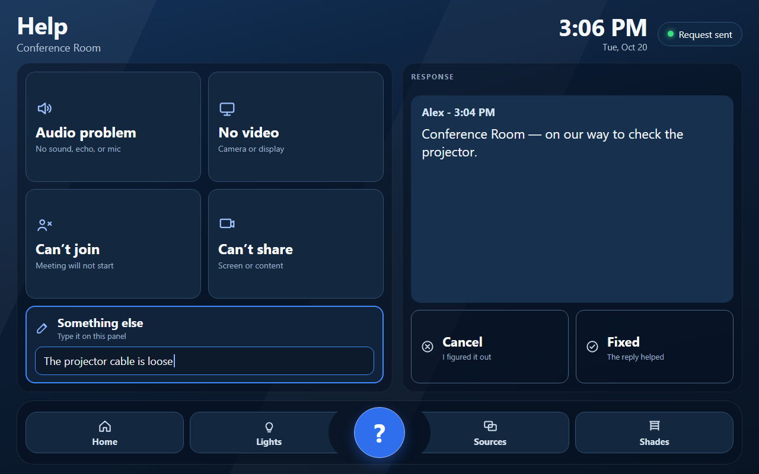
This picture is only an example of what the room panel might look like. It is not the finished screen. Button names, icons, colors, and the bar along the bottom can be different in each room. The idea is a few simple problem buttons, a place to type something else, and a reply that shows the person's name and the time on one line, such as Alex - 3:04 PM. The program can have up to eight problem buttons. This picture shows four. A clock at the top, with the date underneath, is the sort of thing the finished page will have too.
What you hand back
Two web addresses (the alert URL and the reply URL), one secret, and the exact room names.
The addresses are long and they contain sig=. Treat them like passwords.

The picture, in order
Read this once before you click anything.
Step | What happens
1 | The panel calls your alert flow and sends the room name and the problem.
2 | That flow posts a message into one group chat, as the Flow bot.
3 | A person on your team types a new message in that same chat. The message contains the room name.
4 | A second flow saves that message in a SharePoint list.
5 | Every 15 seconds the panel calls your reply flow. That flow reads the list and sends the answer back.
6 | The panel shows the person's name and the time on one line, then the words.

Use the trigger that can watch one chat
Two triggers in the list have almost the same name. They do not do the same thing.
Do not choose “When a new chat message is added.” That one runs for every chat the flow owner belongs to. A message in some other chat would start the flow, and there is no way to limit it to Room Help.
Choose “When a new message is added to a chat or channel.” That one asks you to pick a chat. Pick the Room Help chat, and no other chat.

Before you build the flows
- Make one group chat. Name it Room Help. This is a chat, not a channel.
- Put the on-call people in the chat. Put the person who will own the flows in the chat too. The owner must be a member.
- In the Teams admin center, allow the Workflows app if your tenant blocks it.
- Ask whoever runs the Crestron network to allow the processor to open outbound TCP port 443 to the internet. The flows live on a Microsoft address that ends in logic.azure.com.
- If a flow will not save and the error says data loss prevention, ask the Power Platform admin to allow the Teams connector and HTTP together.

The processor is not a user
On both webhook triggers, set Who can trigger the flow? to Anyone.
Anyone is safe only because you also check the secret header below. If security will not allow Anyone, stop and tell the programmer. Do not invent a Microsoft login for the processor.

Make a list that remembers the latest answer
The panel asks "any answer yet?" over and over. Teams will not store that for you. A SharePoint list will.
- In the same team's SharePoint site, create a list named Room Help Replies.
- You need four columns. Title is already there. Rename Title to Room. Add Sender (single line of text), Reply text (multiple lines of text), and Reply time (single line of text).
- Add one row for every room that will have a Help button. Type the room name in Room exactly as it should appear in the chat. Example: Conference Room. Spelling and capitals matter.
- Send that exact list of names to the programmer. The panel, the chat, and this list must all use the same spelling.

Flow 1 — Alert. This one gets a web address.
Create an automated cloud flow. The trigger is When a Teams webhook request is received. Set Anyone, as above. Copy the HTTP URL. That whole URL, including sig=, is the alert URL.
The panel sends JSON like this. Your flow does not build this. It arrives.
{
"room": "Conference Room",
"action": "help",
"issue": "Audio problem",
"message": "Urgent - Conference Room: Audio problem"
}

action is one of three words: help, cancel, or fixed. Post the message field into the chat. You do not have to assemble the sentence yourself.
- Add Post a message in a chat or channel. Pick the Room Help group chat. The message text is the message field from the trigger.
- When action equals help, also @mention the on-call people in that same post. Use the mention button in the message box, then the message field. Do not @mention on cancel or fixed.
- On help, cancel, and fixed, clear that room's row in Room Help Replies. Set Sender, Reply text, and Reply time back to blank. Do this on help as well, or yesterday's answer will show up again.
- Add a Response action. Status code 200. The body can be empty.
- First action in the flow, before the post: check the header x-room-help-secret. If it is not the secret you agreed, respond 401 and stop. Header names may arrive in lowercase.

What the chat should show
Help: Urgent - Conference Room: Audio problem
Cancel: Conference Room cancelled the request. They figured it out.
Fixed: Conference Room reports the issue is fixed.
The word Urgent plus the @mention is the urgent signal for this version. The red Important flag inside Teams is optional and comes later. Do not wait on it.

Flow 2 — Save a human answer. This one has no web address.
Create an automated cloud flow. Trigger: When a new message is added to a chat or channel. Message type: Group chat. Pick Room Help and only Room Help.
- Add Get message details. Message type is the same group chat. Message is the message id from the trigger. This trigger often gives you an id and not the words.
- Continue only when the sender is a person. If the Flow bot wrote it, stop. Saving the bot's own alert makes the panel repeat the alert back as if IT had answered.
- Get items from Room Help Replies. In a loop, if the message text contains that row's Room value, update the row. Sender is the person's display name. Reply text is the message body. Reply time is the created time.
Paste this into Reply time. It stores UTC, which is what the panel expects.
formatDateTime(outputs('Get_message_details')?['body/createdDateTime'], 'yyyy-MM-ddTHH:mm:ssZ')

The words are in outputs('Get_message_details')?['body']?['body']?['content']. The sender name is outputs('Get_message_details')?['body']?['from']?['user']?['displayName']. The doubled body is not a typo.
If the panel shows <p> tags
Teams sometimes sends the message as HTML. If the panel shows <p> or </p>, tell the programmer. Do not try to clean it until you see it on a test.

Flow 3 — Reply. This one gets the second web address.
Another When a Teams webhook request is received trigger. Anyone. Copy this HTTP URL. This is the reply URL. Check the same secret header, and stop with 401 when it is wrong.
The panel sends this, about every 15 seconds, while a request is still open:
{ "room": "Conference Room" }

- Find the Room Help Replies row whose Room equals that room value.
- If Reply text is filled in, respond 200 with JSON. Use the column values. at must be the Reply time you saved.
- If Reply text is blank, respond 200 with an empty JSON object: { }
- Do not clear the row here. The panel asks many times and needs the same answer until the next help, cancel, or fixed.
A filled-in answer looks like this. sender, text, and at are the names the panel looks for. Do not rename them unless you write the new names on the last page.
{
"sender": "Alex",
"text": "Conference Room - on our way",
"at": "2026-10-20T15:04:00Z"
}

How your team answers
This is the part people get wrong. Print it and put it with the on-call notes.
Do this | Do not do this
Type a new message in the Room Help chat. | Tap Reply under the alert. A thread often never reaches the panel.
Start with the room name, spelled like the list. Conference Room - on our way | On our way with no room name. The flow cannot tell which room you mean.
Send it as a normal message from your own Teams account. | Edit an old message. The trigger does not run on edits.
One answer for one room. | Answer two rooms in one sentence unless both room names are in the text.

The panel keeps the last answer on screen after Cancel or Fixed. The next Help clears it.

What the panel does, so the hours are not a surprise
You do not set these. The programmer does. They are here so a Friday test does not look broken on Monday.
- Something else is the text box on the Help page. Tapping it opens the panel keyboard, which is not part of the page itself. The typed words are the problem. There is no QR code and no phone link.
- After a successful help, the panel keeps calling the reply URL even if the person leaves the Help page.
- Cancel means they figured it out. Fixed means your reply helped. Both post another line in the chat and stop the calls.
- By default the panel stops listening 9 hours after the press. Nine hours from 8:00 to 5:00 is one work day.
- If the programmer turns on business hours, nights, weekends, and holidays do not count toward those 9 hours, and the panel does not call the reply URL outside 8:00 to 5:00 on weekdays. A holiday is a wire in the Crestron program for that day. It is not a Teams setting.
- With business hours on, a press at Tuesday 6:30 PM stays open and clears at Wednesday 5:00 PM. A Friday morning press can still be open Monday morning.

Test it with the programmer
- They press Audio problem for one room whose name is in the list.
- Within a few seconds the chat shows Urgent - Conference Room: Audio problem, with the @mention.
- You type a new message, not a reply: Conference Room - checking audio
- Within about 20 seconds the panel shows a line such as Alex - 3:04 PM, then the words.
- They press Cancel. The chat shows the cancel line. That room's row in the list is blank again.
- Change the secret on one flow only, press Help again, and confirm nothing new appears in the chat. Put the secret back.

When it does not work
What you see | Look here
Nothing new in the chat | Alert URL pasted in full, flow is turned on, Who can trigger is Anyone, processor can use port 443.
401 in the flow run | The secret header does not match. Name is x-room-help-secret unless you changed it on the last page.
Chat line is there, panel stays empty | You used Reply, the room name spelling does not match, flow 2 is off, or the reply URL is wrong.
Panel repeats the alert | Flow 2 is saving the Flow bot. Stop when the sender is not a person.
Panel shows an old answer | Flow 1 did not blank the SharePoint row on the new help.
Panel says it could not reach support | The flow returned something other than 200, or the processor could not open the address.

Fill this in and send it back
Send the secret in a different message from the two URLs when you can. Write "same as the document" only when you did not rename anything.
Item | Your value
Alert URL
Reply URL
Secret header name | x-room-help-secret
Secret
Chat name | Room Help
Room names, exact | Conference Room
JSON names changed? | No. room, action, issue, message, sender, text, at
Who can trigger | Anyone, on both webhook flows
Owner of the flows

You are done when
Both flows are on, the list has one row per room, a test help shows in the chat, and a new message that contains the room name shows on the panel with the name and time on one line, then the words.

